Instituto Politécnico Nacional

Escuela Superior de Cómputo

Fundamentos de

Diseño Digital

Práctica no. 2:

Minimización Algebraica

Profesor: Fernando Aguilar Sánchez

Alumno: Calva Hernández José Manuel

Grupo: 2 CM2

## Desarrollo

1. Diseñe un comparador de magnitud de dos bits. Observe la tabla funcional y recuerde que tiene dos entradas y tres salidas. Arme su circuito resultante y verifique sus resultados.

|  |  |  |  |  |  |
| --- | --- | --- | --- | --- | --- |
| # | A | B | F1  A<B | F2  A=B | F3  A>B |
| 0 | 0 | 0 | 0 | 1 | 0 |
| 1 | 0 | 1 | 1 | 0 | 0 |
| 2 | 1 | 0 | 0 | 0 | 1 |
| 3 | 1 | 1 | 0 | 1 | 0 |

* 1. Coloque la solución del problema y dibuje su circuito lógico.

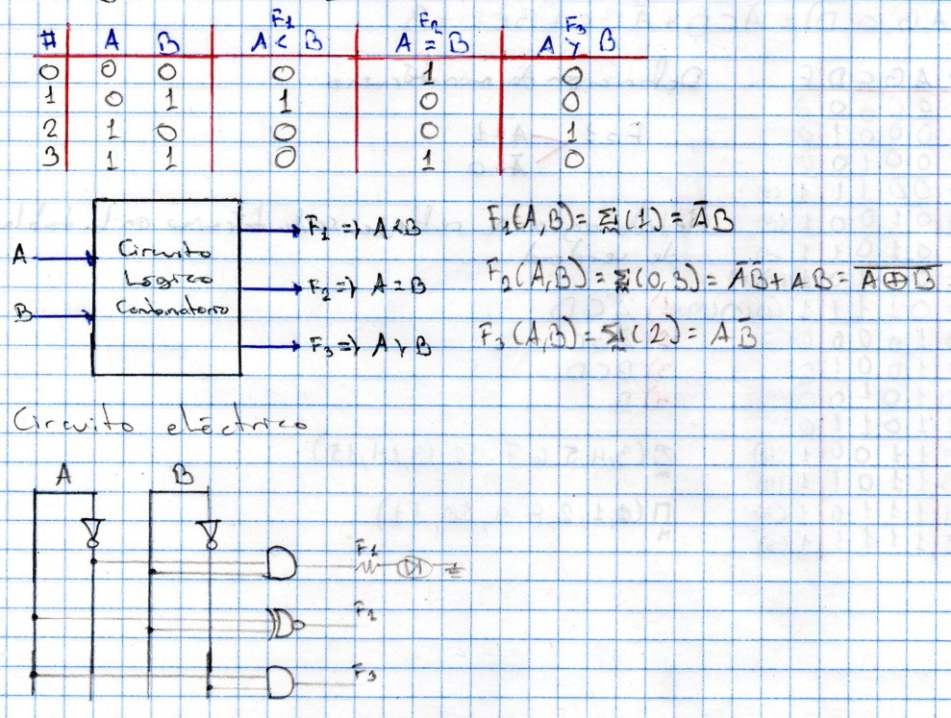

1. Diseñe un generador de Código Gray de 4 bits, y arme su circuito para verificar su funcionamiento.

|  |  |  |  |  |  |  |  |  |
| --- | --- | --- | --- | --- | --- | --- | --- | --- |
| Código Gray | | | | | | | | |
| # | A | B | C | D | F1 | F2 | F3 | F4 |
| 0 | 0 | 0 | 0 | 0 | 0 | 0 | 0 | 0 |
| 1 | 0 | 0 | 0 | 1 | 0 | 0 | 0 | 1 |
| 2 | 0 | 0 | 1 | 0 | 0 | 0 | 1 | 1 |
| 3 | 0 | 0 | 1 | 1 | 0 | 0 | 1 | 0 |
| 4 | 0 | 1 | 0 | 0 | 0 | 1 | 1 | 0 |
| 5 | 0 | 1 | 0 | 1 | 0 | 1 | 1 | 1 |
| 6 | 0 | 1 | 1 | 0 | 0 | 1 | 0 | 1 |
| 7 | 0 | 1 | 1 | 1 | 0 | 1 | 0 | 0 |
| 8 | 1 | 0 | 0 | 0 | 1 | 1 | 1 | 0 |
| 9 | 1 | 0 | 0 | 1 | 1 | 1 | 1 | 1 |
| 10 | 1 | 0 | 1 | 0 | 1 | 1 | 1 | 1 |
| 11 | 1 | 0 | 1 | 1 | 1 | 1 | 1 | 0 |
| 12 | 1 | 1 | 0 | 0 | 1 | 0 | 1 | 0 |
| 13 | 1 | 1 | 0 | 1 | 1 | 0 | 1 | 1 |
| 14 | 1 | 1 | 1 | 0 | 1 | 0 | 0 | 1 |
| 15 | 1 | 1 | 1 | 1 | 1 | 0 | 0 | 0 |

* 1. Coloque la solución de su problema y dibuje su circuito lógico obtenido.

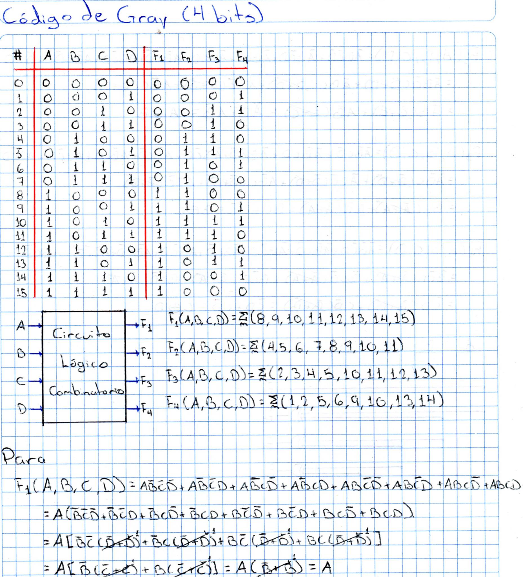



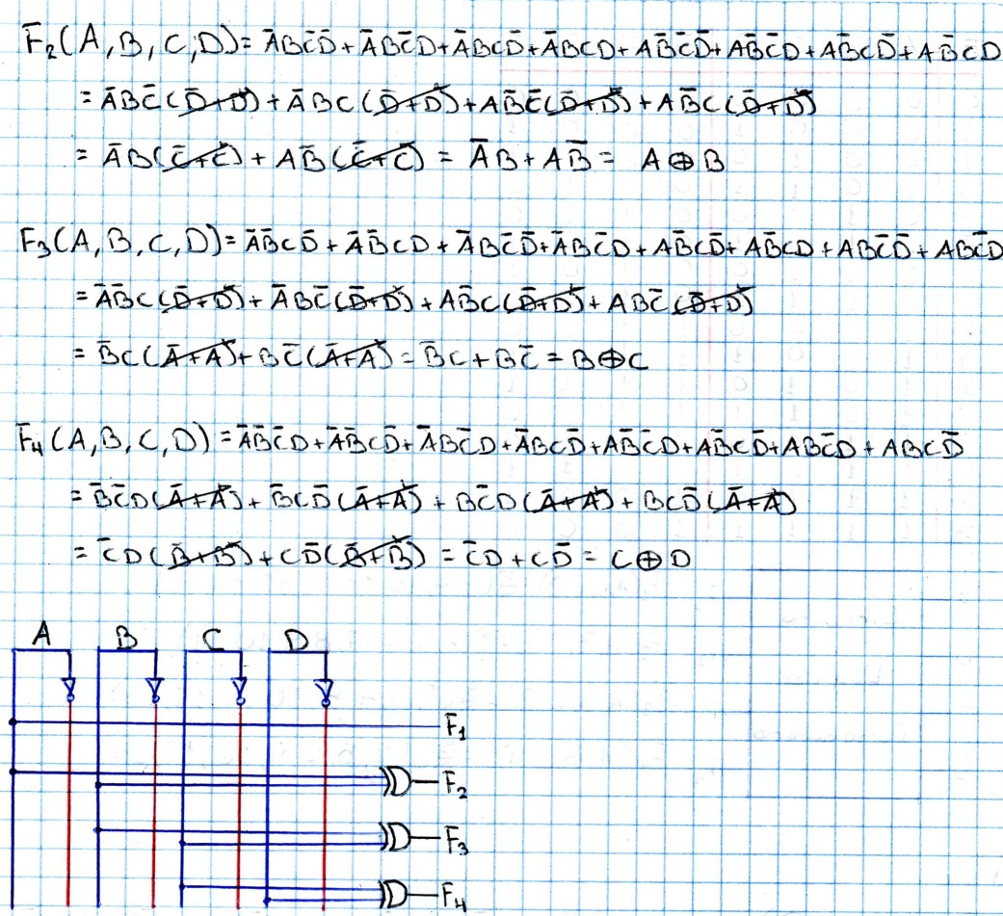

1. Código BCD a 7 segmentos

|  |  |  |  |  |  |  |  |  |  |  |  |
| --- | --- | --- | --- | --- | --- | --- | --- | --- | --- | --- | --- |
| # | A | B | C | D | a | b | c | d | e | f | g |
| 0 | 0 | 0 | 0 | 0 | 1 | 1 | 1 | 1 | 1 | 1 | 0 |
| 1 | 0 | 0 | 0 | 1 | 0 | 1 | 1 | 0 | 0 | 0 | 0 |
| 2 | 0 | 0 | 1 | 0 | 1 | 1 | 0 | 1 | 1 | 0 | 1 |
| 3 | 0 | 0 | 1 | 1 | 1 | 1 | 1 | 1 | 0 | 0 | 1 |
| 4 | 0 | 1 | 0 | 0 | 0 | 1 | 1 | 0 | 0 | 1 | 1 |
| 5 | 0 | 1 | 0 | 1 | 1 | 0 | 1 | 1 | 0 | 1 | 1 |
| 6 | 0 | 1 | 1 | 0 | 1 | 0 | 1 | 1 | 1 | 1 | 1 |
| 7 | 0 | 1 | 1 | 1 | 1 | 1 | 1 | 0 | 0 | 0 | 1 |
| 8 | 1 | 0 | 0 | 0 | 1 | 1 | 1 | 1 | 1 | 1 | 1 |
| 9 | 1 | 0 | 0 | 1 | 1 | 1 | 1 | 1 | 0 | 1 | 1 |
| 10 | 1 | 0 | 1 | 0 | X | X | X | X | X | X | X |
| 11 | 1 | 0 | 1 | 1 | X | X | X | X | X | X | X |
| 12 | 1 | 1 | 0 | 0 | X | X | X | X | X | X | X |
| 13 | 1 | 1 | 0 | 1 | X | X | X | X | X | X | X |
| 14 | 1 | 1 | 1 | 0 | X | X | X | X | X | X | X |
| 15 | 1 | 1 | 1 | 1 | X | X | X | X | X | X | X |

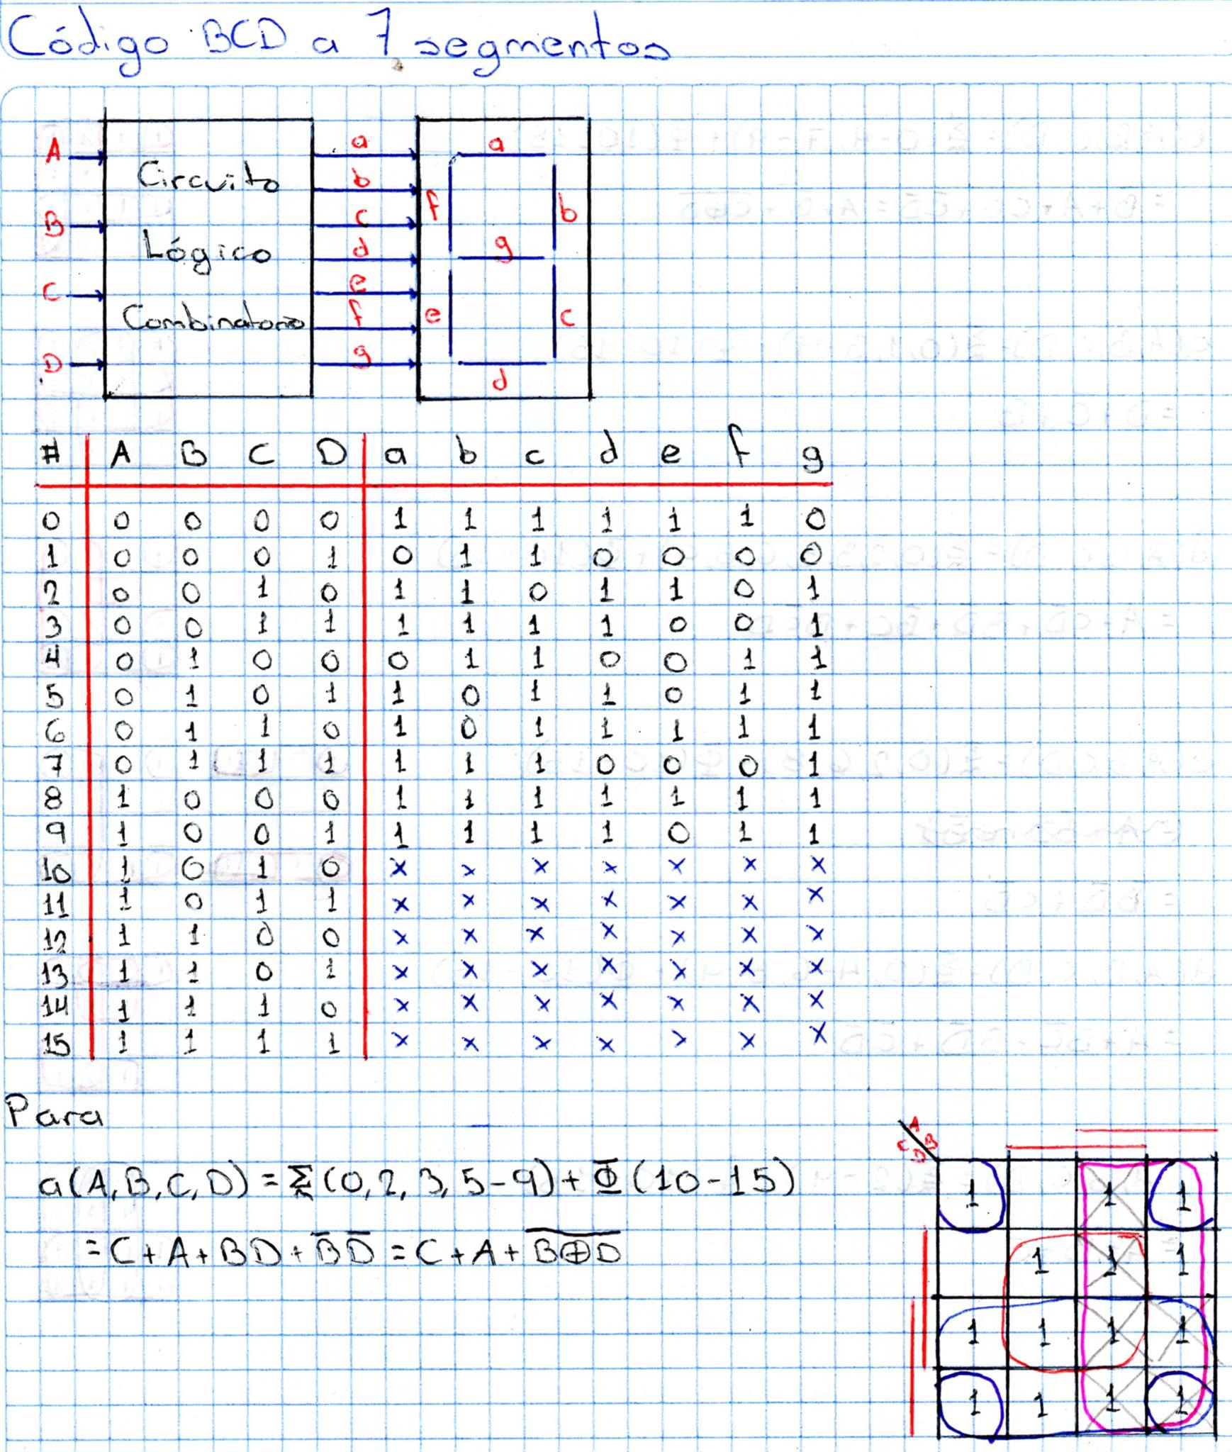



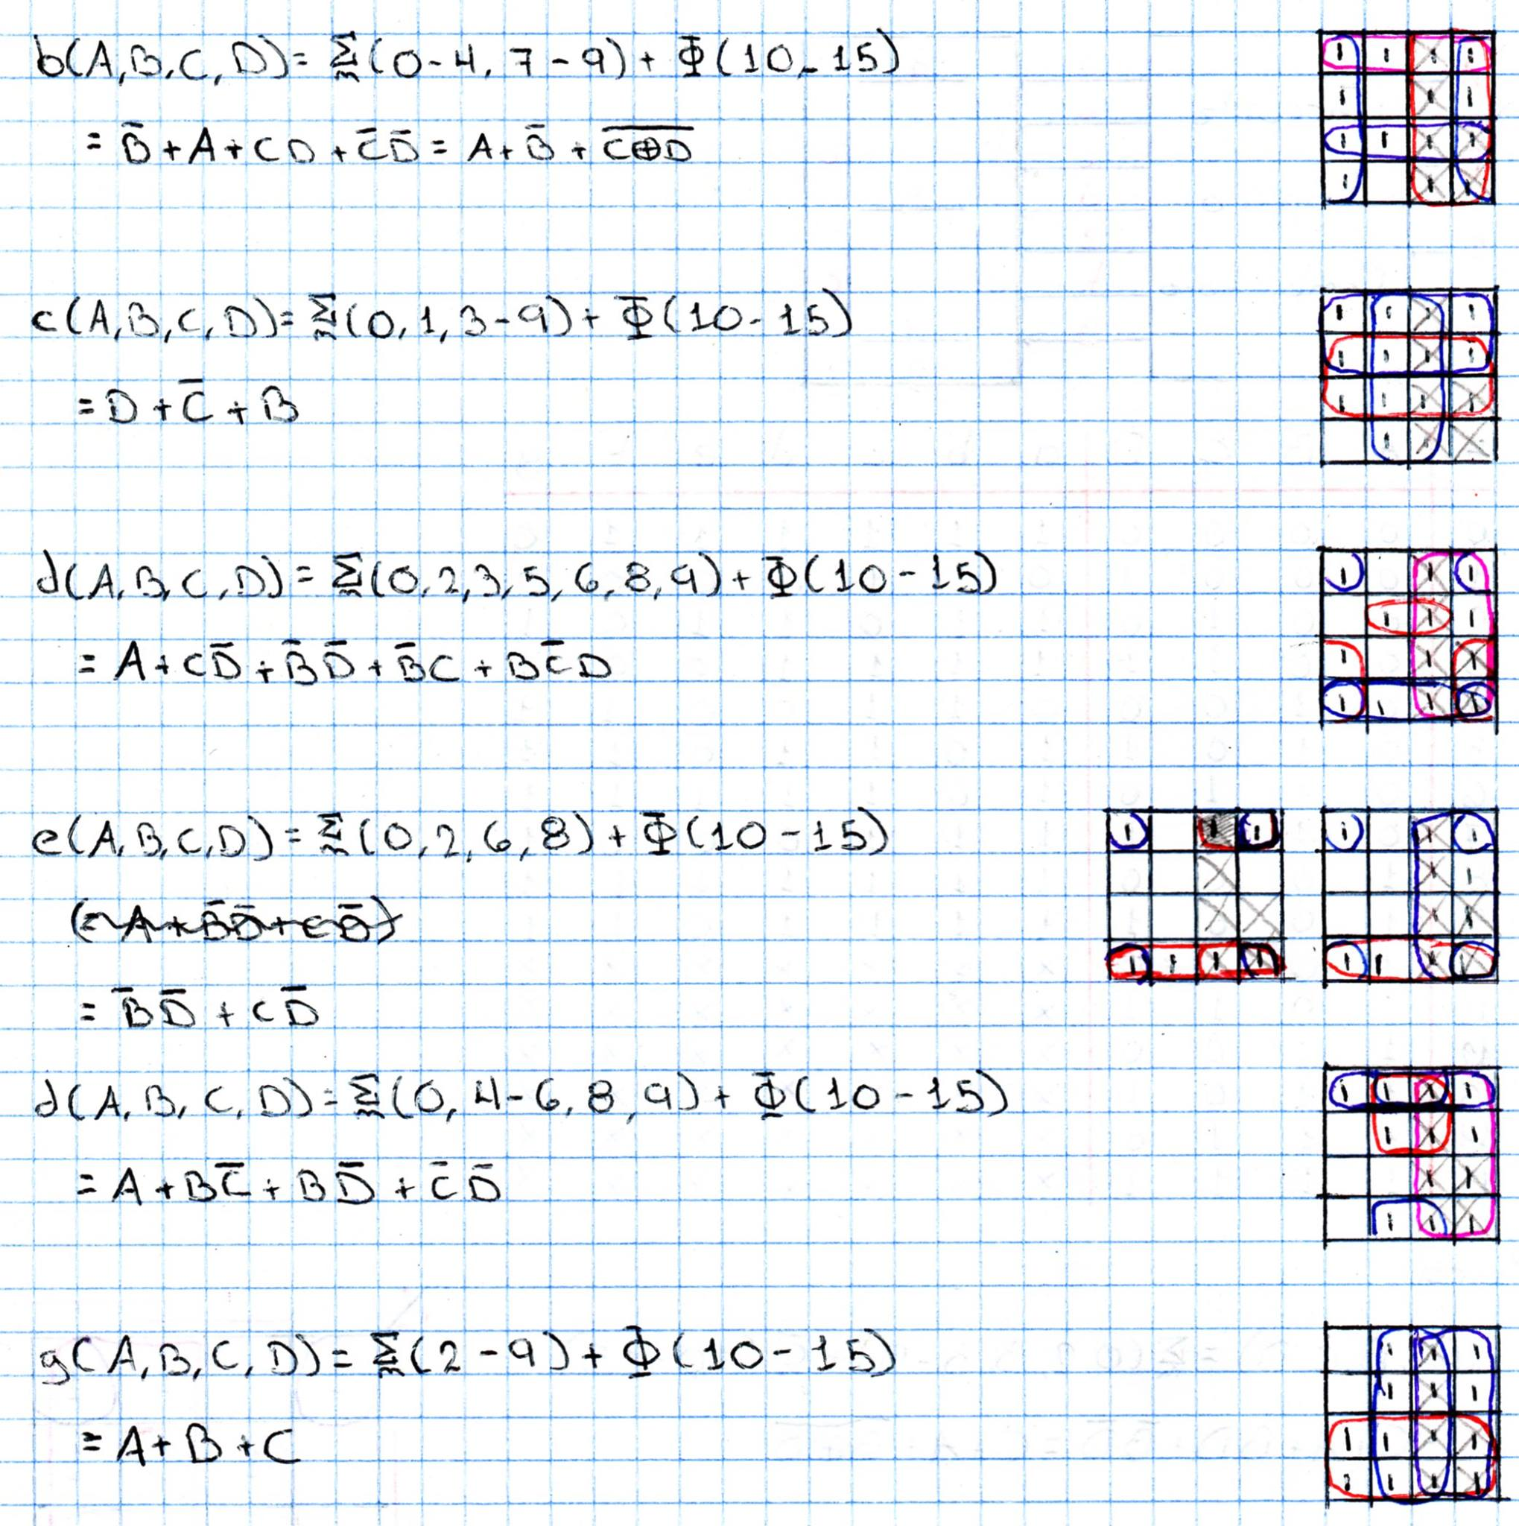

# Circuito Armado

